CHAPTER 1
INTRODUCTION
1.1 WIRELESS NETWORK
A wireless network is a flexible data communications system, which uses wireless media such as radio frequency technology to transmit and receive data over the air, minimizing the need for wired. Wireless networks are used to augment rather than replace wired networks and are most commonly used to provide last few stages of connectivity between a mobile user and a wired network.
Wireless networks use electromagnetic waves to communicate information from one point to another without relying on any physical connection^{[1]}. Radio waves are often referred to as radio carriers because they simply perform the function of delivering energy to a remote receiver. The data being transmitted is superimposed on the radio carrier so that it can be accurately extracted at the receiving end.
Once data is superimposed (modulated) onto the radio carrier, the radio signal occupies more than a single frequency, since the frequency or bit rate of the modulating information adds to the carrier. Multiple radio carriers can exist in the same space at the same time without interfering with each other if the radio waves are transmitted on different radio frequencies. To extract data, a radio receiver tunes in one radio frequency while rejecting all other frequencies. The modulated signal thus received is then demodulated and the data is extracted from the signal. Wireless networks offer the following advantages over traditional wired networks:

- Mobility: provide mobile users with access to real-time information so that they can roam around in the network without getting disconnected from the network. This mobility supports productivity and service opportunities not possible with wired networks.
- Installation speed and simplicity: installing a wireless system can be fast and easy and can eliminate the need to pull cable through walls and ceilings.
- Reach of the network: the network can be extended to places which can not be wired
- More Flexibility: wireless networks offer more flexibility and adapt easily to changes in the configuration of the network.
- Reduced cost of ownership: while the initial investment required for wireless network hardware can be higher than the cost of wired network hardware, overall installation expenses and life-cycle costs can be significantly lower in dynamic environments.
- Scalability: wireless systems can be configured in a variety of topologies to meet the needs of specific applications and installations. Configurations can be easily changed and range from peer-to-peer networks suitable for a small number of users to large infrastructure networks that enable roaming over a broad area.
1.2 MOBILE ADHOC NETWORK (MANET)
Mobile Adhoc NETworks (MANET) are self-organizing and self-configuring multi-hop wireless networks capable of adaptive re-configuration when they are affected by node mobility. A mobile adhoc network is composed of peer nodes with equal networking capabilities which are able to function as mobile routers i.e., to forward packets and maintain routes.
Packets can be forwarded in multi-hops from the source nodes to the destination nodes with no need for underlying fixed network infrastructure (e.g. routers and base stations). Therefore, mobile adhoc networks are not constrained in their deployment by any need for underlying infrastructure and they can be deployed rapidly in situations where wireless access to a backbone is impossible and an infrastructure is difficult to install (e.g., disaster recovery).
Due to the advances in low-cost and low power consumption, Wireless Mobile Networks (MANETs) have gained variety of attentions and resulted in thousands of peer-reviewed publications. Significant results in this area have enabled multiple applications used in military and civilian. Most of researches and deployments on MANETs are concerned with scalar mobile networks that measure physical phenomena, such as temperature, pressure, humidity, or location of objects that can be transferred through low-bandwidth and delay-tolerant data streams. In general, MANETs are designed with purpose of data-only delay-tolerant applications without high bandwidth requirements. As more and more wireless multimedia devices are equipped with multiple network interfaces, it becomes increasingly common for a wireless video device to be connected to more than one access networks employing either a homogenous or heterogeneous, the multi homed technology is becoming an important technology in wireless transmission. Due its feature of multi homing, Stream Control Transport Protocol (SCTP) shows its advantages on the serious data loss nature of wireless networks, and its performance adopted in multimedia streaming services over multi homed wireless networks has been studied widely. Thus, SCTP will become a promising transport protocol for packet delivery over heterogeneous network.
In addition to the traditional problems of wireless networks (bandwidth optimization and transmission quality enhancement) mobile adhoc networks introduce new issues such as adhoc addressing, increased energy constraints, self-configuration and adaptive reconfiguration, as network topology is affected by node mobility. Furthermore, because of the real time nature of adhoc network applications (e.g., collaborative mobile computing, battlefield communications, emergency search and rescue operations, disaster recovery), data traffic is routed under timing constraints requiring proactive route construction and maintenance procedures.

1.2.1 MANET Features
MANET has the following features:
1) Autonomous terminal. In MANET, each mobile terminal is an autonomous node, which may function as both a host and a router. In other words, besides the basic processing ability as a host, the mobile nodes can also perform switching functions as a router. So usually endpoints and switches are indistinguishable in MANET.
2) Distributed operation. Since there is no background network for the central control of the network operations, the control and management of the network is distributed among the terminals. The nodes involved in a MANET should collaborate amongst themselves and each node acts as a relay as needed, to implement functions e.g. security and routing.
3) Multihop routing. Basic types of adhoc routing algorithms can be single-hop and multihop, based on different link layer attributes and routing protocols. Single-hop MANET is simpler than multihop in terms of structure and implementation, with the cost of lesser functionality and applicability. When delivering data packets from a source to its destination out of the direct wireless transmission range, the packets should be forwarded via one or more intermediate nodes.
4) Dynamic network topology. Since the nodes are mobile, the network topology may change rapidly and unpredictably and the connectivity among the terminals may vary with time. MANET should adapt to the traffic and propagation conditions as well as the mobility patterns of the mobile network nodes. The mobile nodes in the network dynamically establish routing among themselves as they move about, forming their own network on the fly. Moreover, a user in the MANET may not only operate within the adhoc network, but may require access to a public fixed network.
5) Fluctuating link capacity. The nature of high bit-error rates of wireless connection might be more profound in a MANET. One end-to-end path can be shared by several sessions. The channel over which the terminals communicate is subject to noise, fading, and interference, and has less bandwidth than a wired network. In some scenarios, the path between any pair of users can traverse multiple wireless links and the link themselves can be heterogeneous.
6) Light-weight terminals. In most cases, the MANET nodes are mobile devices with less CPU processing capability, small memory size, and low power storage. Such devices need optimized algorithms and mechanisms that implement the computing and communicating functions.

1.2.2 MANET Applications
With the increase of portable devices as well as progress in wireless communication, adhoc networking is gaining importance with the increasing number of widespread applications. adhoc networking can be applied anywhere where there is little or no communication infrastructure or the existing infrastructure is expensive or inconvenient to use. adhoc networking allows the devices to maintain connections to the network as well as easily adding and removing devices to and from the network. The set of applications for MANETs is diverse, ranging from large-scale, mobile, highly dynamic networks, to small, static networks that are constrained by power sources. Besides the legacy applications that move from traditional infrastructured environment into the adhoc context, a great deal of new services can and will be generated for the new environment.
Typical applications of MANET include:
1) Military battlefield. Military equipment now routinely contains some sort of computer equipment. adhoc networking would allow the military to take advantage of commonplace network technology to maintain an information network between the soldiers, vehicles, and military information head quarters. The basic techniques of adhoc network came from this field.
2) Commercial sector. Adhoc can be used in emergency/rescue operations for disaster relief efforts, e.g. in fire, flood, or earthquake. Emergency rescue operations must take place where non-existing or damaged communications infrastructure and rapid deployment of a communication network is needed. Information is relayed from one rescue team member to another over a small handheld. Other commercial scenarios include e.g. ship-to-ship adhoc mobile communication, law enforcement, etc.
3) Local level. adhoc networks can autonomously link an instant and temporary multimedia network using notebook computers or palmtop computers to spread and share information among participants at a e.g. conference or classroom. Another appropriate local level application might be in home networks where devices can communicate directly to exchange information. Similarly in other civilian environments like taxicab, sports stadium, boat and small aircraft, mobile adhoc communications will have many applications.
4) Personal Area Network (PAN). Short-range MANET can simplify the intercommunication between various mobile devices (such as a PDA, a laptop, and a cellular phone). Tedious wired cables are replaced with wireless connections. Such an Adhoc network can also extend the access to the Internet or other networks by mechanisms e.g. Wireless LAN (WLAN), GPRS, and UMTS.

1.2.3 MANET Challenges
Regardless of the attractive applications, the features of MANET introduce several challenges which include:

- Routing. Since the topology of the network is constantly changing, the issue of routing packets between any pair of nodes becomes a challenging task. Most protocols should be based on reactive routing instead of proactive. Multicast routing is another challenge because the multicast tree is no longer static due to the random movement of nodes within the network. Routes between nodes may potentially contain multiple hops, which is more complex than the single hop communication.
2) Security and Reliability. In addition to the common vulnerabilities of wireless connection, an adhoc network has its particular security problems due to e.g. nasty neighbor relaying packets. The feature of distributed operation requires different schemes of authentication and key management. Further, wireless link characteristics introduce also reliability problems, because of the limited wireless transmission range, the broadcast nature of the wireless medium (e.g. hidden terminal problem), mobility-induced packet losses, and data transmission errors.
3) Quality of Service (QoS). Providing different quality of service levels in a constantly changing environment will be a challenge. The inherent stochastic feature of communications quality in a MANET makes it difficult to offer fixed guarantees on the services offered to a device. An adaptive QoS must be implemented over the traditional resource reservation to support the multimedia services.
4) Internetworking. In addition to the communication within an adhoc network, internetworking between MANET and fixed networks (mainly IP based) is often expected in many cases. The coexistence of routing protocols in such a mobile device is a challenge for the harmonious mobility management.
5) Power Consumption. For most of the light-weight mobile terminals, the communication-related functions should be optimized for lean power consumption. Conservation of power and power-aware routing must be taken into consideration.

1.3 CLUSTERING
In mobile adhoc network references, clustering can be defined as a notional arrangement of the dynamic nodes into various groups. These virtual collections of nodes are grouped together regarding their relative transmission range proximity to each other that allows them to establish a bidirectional link. The diameter size of the clusters determines the control architectures as single-hop clustering and multi-hop (K-hop) clustering. In single-hop clustering every member node is never more than 1-hop from a central coordinator - the cluster head. Thus all the member nodes remain at most two hops distance away from each other within a logical cluster.
A typical mobile adhoc network is illustrated in Fig 1.1 with flat and cluster structure. The small circles in the Fig 1.1 represent the individual wireless nodes in the network and the lines joining the circles show the sequential single hops of the wireless link among the wireless nodes. Each node is identified with an ID number (i.e.1–16) and Fig 1.1 (a) illustrates each node bearing equal responsibility in its role as a router for forwarding packets to every other node in a flat architecture MANET.
This type of arrangement is prone to an inundation of information known as message flooding which offers better routing efficiency but significantly diminishes the Medium Access Control (MAC) layer efficacy. Using clustering schemes, improved spatial reuse, scalability, throughput and energy efficiency are achievable from better protocol performance of the MAC layer.
At the network layer, clustering helps improve routing through reduction of the routing table size and a decrease in transmission overhead (resultant of routing table updates) following topological changes. The condensing and the ability of each node to store only fractional amounts of data (of the total network routing information) achieved through clustering helps aggregate topology information. Clustering schemes generally utilize three types of nodes which are chosen to assume different roles according to specific criteria briefly outlined below:
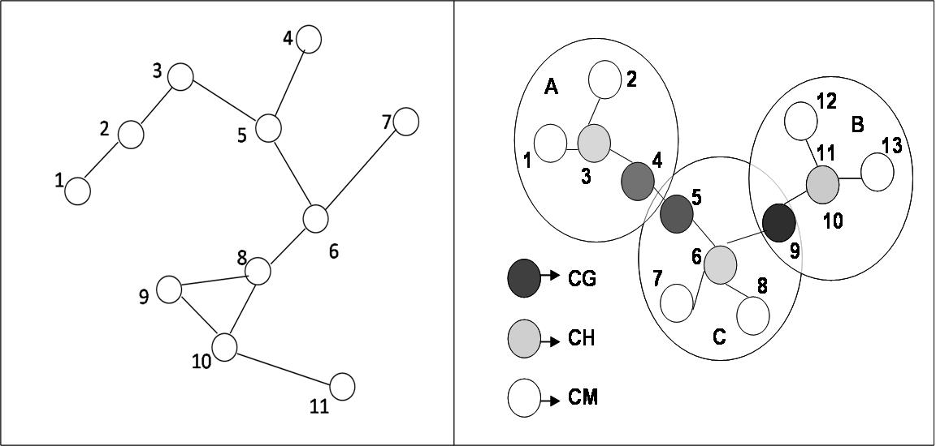
Figure 1.1 (a) Flat network structure Figure 1.1 (b) Clustered network structure

Cluster head nodes: for any efficient cluster (subsets of nodes in a network satisfying a particular property) operation there must be a support or backbone to sustain all essential control functions such as channel access, routing, calculation of the routes for longer-distance messages, bandwidth allocation, forwarding inter-cluster packets, power control and virtual-circuit support. This support or backbone takes the form of connected cluster heads, in managerial role; linked either directly or via gateway nodes and they will have the subordinate nodes of that cluster linked to them.
Another function of cluster heads is internal node communication, to forward inter cluster messages. To send a packet an ordinary node must first direct it to its ‘superior’ its directly connected cluster head. Should the receiver share the same cluster location, cluster head will direct the packet to it. However, should the receiver be in a different cluster location, cluster head will route it to another cluster head (directly) connected to the receiver and the new cluster head then directs it to the final destination.

Cluster Gateway Nodes: Is a node that works as the common or distributed access point for two cluster heads. When a node remains within the transmission range of two cluster heads as the node 2 in Figure 1.1(b) it is called as the ordinary gateway for two corresponding clusters. And a node having one cluster head as an immediate neighbor in addition to which it can reach a second cluster head in two hops as node 5 or 6 is a distributed gateway that is linked to another distributed gateway of other cluster. Both of the distributed gateways provide the path for the inter-cluster communication.

Ordinary nodes (cluster member): As the name suggests, ordinary nodes do not perform any other function beyond a normal node role. They are members of an exclusive cluster independent of neighbors residing in a different cluster.

Classification of Clustering
From the detailed survey, Clustering scheme can be classified into the following five methods.
- Low maintenance Clustering: Providing a cluster infrastructure for upper layer applications with minimized clustering-related maintenance cost.
- Mobility Aware Clustering: Utilizing mobile nodes’ mobility behavior for cluster construction and maintenance and assigning mobile nodes with low relative speed to the same cluster to tighten the connection in such a cluster.
- Energy Efficient Clustering: Avoiding unnecessary energy consumption or balancing energy consumption for mobile nodes in order to prolong the lifetime of mobile terminals and a network.
- Load-Balancing Clustering: Distributing the workload of a network more evenly into clusters by limiting the number of mobile nodes in each cluster in a defined range.
- Combined Metrics-Based Clustering: Considering multiple metrics in cluster configuration, including node degree, mobility, battery energy, cluster size, etc., and adjusting their weighting factors for different application scenarios.

1.4 MOBILITY AWARE CLUSTERING
Mobility is a prominent characteristic of MANETs, and is the main factor affecting topology change and route invalidation. It is important to take the mobility metric into account in cluster construction in order to form a stable cluster structure and decrease its influence on cluster topology.
Mobility-aware clustering indicates that the cluster architecture is determined by the mobility behavior of mobile nodes. The idea is that by grouping mobile terminals with similar speed into the same cluster, the intra-cluster links can become more tightly connected. Then the re-affiliation and re-clustering rate can be naturally decreased.

1.5 MOBILITY PREDICTION METHODS
We classify the mobility prediction methods for mobile Adhoc networks into three categories as follows
1. Movement history based prediction methods, which predict the “future” location of a mobile user based on his movement history (i.e., previous user movement patterns).
2. Physical topology based mobility prediction methods, which base their prediction on the use of the characteristics of MANET’s physical topology and therefore, require the use of a Global Positioning System (GPS) to obtain exact node location and mobility information.
3. Logical topology based mobility prediction methods, which choose a logical topology of the MANET (e.g. a clustering structure) over which they apply their prediction process. On the contrary to the previous category, they do not require exact location and mobility information and thus they do not make use of a GPS.
Estimated values of node location and mobility information may be obtained by other means (e.g., using signal attenuation versus traveled distance to estimate internode distances, or inferring the mobility of each node from how different is the neighborhood of the node over time). For each one of the above mentioned categories, we present well-known prediction methods, classifying them according to their applications and/or the specific prediction method they are based on.

1.6 MOBILITY MODEL
A Mobility model should attempt to mimic the movements of real MNs. Changes in speed and direction must occur and they must occur in reasonable time slots. For example, we would not want MNs to travel in straight lines at constant speeds throughout the course of the entire simulation because real MNs would not travel in such a restricted manner.

Seven different synthetic entity mobility models for adhoc networks:
1. Random Walk Mobility Model (including its many derivatives): A simple mobility model based on random directions and speeds.
2. Random Waypoint Mobility Model A model that includes pause times between changes in destination and speed.
3. Random Direction Mobility Model A model that forces MNs to travel to the edge of the simulation area before changing direction and speed.
4. A Boundless Simulation Area Mobility Model A model that converts a 2D rectangular simulation area into a torus-shaped simulation area.
5. Gauss-Markov Mobility Model A model that uses one tuning parameter to vary the degree of randomness in the mobility pattern.
6. A Probabilistic Version of the Random Walk Mobility Model A model that utilizes a set of probabilities to determine the next position of an MN.
7. City Section Mobility Mode A simulation area that represents streets within a city.

1.7 ENERGY EFFICIENCY IN MANET
Energy-efficient and reliable routing are two important requirements in wireless ad hoc networks, where nodes have limited battery power and wireless links are prone to transmission errors. When nodes in the network cooperate to achieve a single goal (e.g., in wireless sensor networks), maximizing the operational lifetime of the network is also an important requirement. While each of these requirements could be achieved separately in ad hoc networks, providing energy-efficient and reliable routing in such a way that the network lifetime is maximized is of significance.

The proposed optimal double search energy-efficient routing schemes can reduce the overall energy consumption in the network. They find routes with the minimum total transmission power required for packet transfer from source to destination. These schemes, however, do not consider reliability of links in route selection. This may result in choosing less reliable routes, which reduces the quality of service. Furthermore, when a packet is lost due to transmission error in lossy links, the link layer and/or the transport layer packet loss recovery mechanisms trigger packet retransmission. This in turn increases the energy consumed to deliver packets across the network. Energy-aware routing schemes proposed in mitigate this drawback by considering reliability of links to find minimum energy routes.

Routing schemes proposed aimed at increasing the operational lifetime of ad hoc networks by taking into account the residual battery energy of nodes. They try to find routes that their constituent nodes are likely to have more battery energy. Such schemes can avoid the use of nodes with low battery energy as relaying nodes, and balance he traffic load in the network. The proposed routing algorithm in takes into account reliability of links and residual battery energy of nodes in route selection. Nevertheless, it may not find minimum-energy routes (as we will verify in this paper) due to the use of max-min route selection scheme.

CHAPTER 2
LITERATURE SURVEY
1. A Survey of Multicast Routing Protocols for Mobile Adhoc Networks
Mobile nodes self organize to form a network over radio links. Multicast routing protocols are faced with the change of producing multihop routing under host mobility and bandwidth constraint^{[5]}. A communication session is achieved either through single hop transmission if the recipient is within the transmission range of the source node, or by relaying through intermediate nodes otherwise. The transmission range of each low power node is linked to each other’s proximity, and out-of-range nodes are routed through intermediate nodes. Multicast routing protocols depends on battery power of the node. This protocols can be divided into application independent based multicast routing and application dependent based multicast routing^{[5]}. The proactive unicast routing protocol maintains consistent, up-to-date routing information. The unicast routing protocol is source initiated on demand unicast method. The adhoc multicast routing protocol utilizing increasing Id numbers (AMRIS) builds a shared tree to deliver multicast data^{[5]}. Most of the multicast routing protocols assume physically flat network architecture with mobile nodes having homogenous capability in terms of network and computing power. Each nodes determine its own location through the use of positioning service. A locator service used by the sender of a packet to determine the location of the destination^{[6]}. With the popularity of MANETs and considering the dynamic network features, integrated criteria, such as philosophies of QOS, power control, reliable and secure for evaluating performances of multicast routing protocols. The minimum hop number path will be selected. The performances based on their topology, initialization and maintenance mechanism base multicast routing protocols^{[6]}. The characteristics, routing metrics and routing philosophies of each of these protocols selected from the class of similar approaches, which can reflect the state of the art research work on multicast routing protocols. The scalability is not only related to multicast routing protocols but also with the mobile adhoc network itself. In adhoc environment, a different addressing approach may be required. Node movement and network portioning makes this task of synchronizing multicast address in adhoc really difficult. The security is the main problem. Each single source multicast routing protocol induces a lot of overhead and thus wastes tremendous network resources in multi source multicast environment.

2. The Efficient Ant Routing Protocol for MANET
A novel meta- heuristic on-demand routing protocol Ant-E, using the Blocking Expanding Ring Search (Blocking-ERS) to control the overhead and local retransmission to improve the reliability in term of packet delivery ratio (PDR)^{[7]}. Ant-E is inspired by the ant-colony optimization (ACO) used to solve complex optimization problems and utilizes a collection of mobile agents as “ants” to perform optimal routing activities. However, collectively ants manage to perform several complicated tasks with a high degree of consistency and adaptivity^{[7]}. ACO protocol for routing in ad hoc network substantially differs from traditional routing protocols. These protocols gather routing information through the repetitive sampling of possible paths between source and destination nodes using artificial ant packets. Ants are biologically blind and thus the communications between ants are indirect in which they sense and follow a chemical substance called pheromone^{[7]}. The packets used in the network can be divided into two classes like data packets and control packets. Data packets represent the information that the end-users exchange with each other. Ant-E contains a special routing table, in which each destination is associated to all interfaces and each interface has a certain probability^{[8]}. Control packets like forward ant (FANT) and a backward ant (BANT) are used to update the routing tables and distribute information about the traffic load in the network. Apart from the above control packets, the neighbor control packets are used to maintain a list of available nodes to which packets can be forwarded node. In Ant-E, data packets would also travel over a route which owns the highest pheromone value in conjunction with the objective of fully utilizing the optimal route. Once the ants have established the pheromone tracks for the source and destination, subsequent data packets are used to maintain the path. The Normalized Routing Load(NRL) for delivery packets, Packet Delivery Ratio and End-to-End delay are achieved in this Ant Colony algorithm^{[8]}. It tends to provide properties such as adaptivity and robustness, which are essential to deal with the challenges of MANET. It uses the blocking ERS and local retransmission along with principles of ant colony to reduce the end-to-end delay and NRL^{[9]}. The scalability problem can arise in large network if the destination node is close to source node. The request message that pass through each node in the network, can be extremely wasteful; especially if the destination node is relatively close to route request originator source.

3. Optimization of MANET Connectivity Via Smart Deployment/Movement of Unmanned Air Vehicles
Unmanned air vehicles (UAVs) can provide important communication advantages to ground-based wireless ad hoc networks. The location and movement of UAVs are optimized to improve the connectivity of a wireless network. In some situations where network robustness is a key issue, it may be desired to guarantee network connectivity in the event that some subsets of the network nodes are disabled^{[10]}. Optimization of the UAV position in only two dimensions, it is straightforward to extend the algorithms to the cases involving altitude as a third dimension. A linear search algorithm is utilized to reduce the complexity of the gradient method. Random Initialization approach generates a number of seeds within the area of the MANET and lets the gradient method ﬁnd the local optima^{[10]}. The location with the smallest value among all the local optima is selected as the initialization. When the gradient is large enough, the UAV ﬂies against the gradient direction with speed proportional to the magnitude of the gradient Link quality is constantly monitored, since it determines the modulation and coding schemes that are employed. Since the physical network topology changes relatively slowly, and since the UAV cannot instantaneously relocate itself, it makes sense to only consider the link quality averaged over several independent fades^{[11]}. All things considered, the update rate for the UAV location can be on the order of at least several seconds. While the speed and heading of the UAV relay are adjusted on the order of every few seconds, this computation only involves the relatively few nodes that are connected to the UAV. The UAV tries to improve the performance around the places where there is a weakest link or on the boundary where the network is divided. As a result, only the information about the nodes around is necessary. Moreover, the UAV mostly serves for the backbone of the network. The network bisection and k-connectivity are also improved by the addition of a UAV to the network^{[11]}. This backbone may be composed of a relatively few key communications nodes, and it is more reasonable to assume that the position and channel condition for these nodes could be known. This technique could be used to deploy multiple UAVs in a sequential manner. This is a problem that would also be a fruitful area of further research. The disadvantage is that the computational complexity is high, particularly when the number of nodes is large. The problems of UAV deployment and movement are formulated to improve the different types of connectivity.

4. Performance Analysis of MANET Routing Protocols in the Presence of Self-Similar Traffic
Nodes forming and Ad Hoc network are required to have the ability to double up as a client, a server, and a router simultaneously. Moreover, these nodes should also have the ability to connect to and automatically configure to start transmitting data over the network. It is impractical to expect a MANET to be fully connected, where a node can directly communicate with every other node in the network. DSR and AODV routing protocols are used to implement this network. Extensive simulations were conducted using NS-2. The Constant Bit Rate(CBR), Exponential and pareto are the methods used int extensive simulations^{[12]}. The Data Packet Delivery ratio is used performing in terms of packet delivery at different speeds using different traffic models. Normalized Protocol Overhead gives an idea of the extra bandwidth consumed by overhead to deliver data traffic^{[12]}. Throughput (messages/second) of the protocol is measured in terms of number of messages delivered per one second. Average End-to-End delay is measured by the average time it takes a data packet to reach the destination. This includes all possible delays caused by buffering during route discovery latency, queuing at the interface queue, retransmission delays at the MAC, propagation and transfer times^{[12]}. This metric is crucial in understanding the delay introduced by path discovery. AODV has maintained a remarkably low and stable overhead throughout the six speeds. The stability in number of routing packets per data packet was due to that fact that AODV engages a Path Discovery only when necessary. The DSR routing protocol has exhibited superior performance in terms of data packet delivery ratio, throughput and end-to-end delay at speeds less than 10 m/s compared to AODV and OLSR. On the other hand, OLSR performed poorly in the presence of a statistically self-similar traffic at high mobility especially in terms of data packet delivery ratio, overhead and delay. As for AODV routing protocols, the results show an average performance, yet a notably stable and low end-to-end delay was observed^{[13]}. Typically, nodes are obliged to use a multi- hop path for transmission, and a packet may pass through multiple nodes before being delivered to its intended destination. Extensive measurements have revealed that traffic follows a self-similar behavior. As a consequence, networks often experience long periods of bursty traffic. Recent evidences show that data traffic is being statistically self-similar. This implies that data traffic will maintain bursty characteristics^{[13]}. A bursty traffic is a traffic that is generated randomly, with peak rates exceeding average rates by factors of eight to ten.

5. Optimal Design of Reliable Network Systems in Presence of Uncertainty
Network designs is based on multiple choices of redundant conﬁgurations, and different available components which can be used to form links^{[13]}. More speciﬁcally, the reliability of a network system can be improved through redundancy allocation, or for a ﬁxed network topology, by selection of highly reliable links between node pairs, yet with limited overall budgets, and other constraints as well. The choice of a preferred network system design requires the estimation of its reliability. However, the uncertainty associated with such estimates must also be considered in the decision process. Two approaches are often used to improve the reliability of a network system. One is to allocate redundant components with similar functionality between two nodes. The allocation of redundancy, however, implies additional cost, weight, and maintenance requirements on the entire network system. The second approach is to implement a single highly reliable component between a pair of nodes, perhaps as a replacement for an existing, less reliable link. Multi-objective GA are utilized to select optimal network designs that balance the dual objectives of high reliability, and low uncertainty in its estimation. Due to the growing exploitation of highly dimensioned and complex network systems, (telecommunication, and others), the tasks of designing and operating highly reliable networks are acquiring increasing signiﬁcance. Estimation of the reliability of a network system is usually based on estimates of the reliability parameters of its constituent lower-level components (nodes & links). The associated disadvantage is that highly reliable components are usually more expensive, but the overall system weight, complexity, and maintenance costs may be reduced compared to resorting to redundancy allocation. Indeed, network system reliability is generally estimated from estimates of the reliability of lower-level components (nodes & links) affected by uncertainties. The propagation of the estimation uncertainty from the components degrades the accuracy of the system reliability estimation. The problem of determining the optimal network design has been addressed within a multi-objective search based on an effective coupling of genetic algorithms, and Monte Carlo simulation, which allows for the explicit consideration of the uncertainties in the network reliability estimates arising from the uncertainties in the components reliability parameters .

6. Energy efficient location based routing using DREAM algorithm for MANET:
A new location based energy efficient scheme with AODV (DREAM-EAODV) protocol is used here. In this scheme energy dependent nodes are do routing with AODV protocol on the basis of location based protocol DREAM^{[14]}. Location based DREAM (Distance routing Effect Algorithm for Mobility) protocol maintains the location of each node on the basis of respective sender and receiver. In Mobile Ad hoc Network (MANET) all the nodes are mobile in nature having limited battery capacity that is called energy. Due to lack of energy and location awareness most of the energy of mobile nodes are wasted and following problems occurs Suddenly loss of session., Due to maximize the loss of packets. , Decreases network survivability and connectivity^{[14]}. Route Overhead is Maximum. The main aim of proposed scheme is to enhance the energy utilization in network .It reduces the end to end latency, routing overhead and increases the throughput. By using location information, DREAM protocol limits the search for a new route. DREAM protocol in MANET requires the information about geographical location of the nodes in network. This location information can be determined by using Global Positioning System .Therefore every node has to have GPS device and extra memory to store location information.

7. Path discovery and selection for energy efficient routing with transmit power control in MANET:

The proposed work called Path Discovery and Selection for Energy Efficient Routing (PDSEER) is designed in such a way that when DSR starts the route discovery after checking its route cache , the required transmit power is set first in order to save energy. Then RSS of the RREQ and node's remaining energy is validated for deciding whether a node can forward the RREQ or not^{[15]}. The data is transmitted after selecting the path that consumes minimum energy. In order to achieve energy efficient reliable transmission, routing here is divided into two parts. One is to discover the path based on Received Signal Strength (RSS) and residual energy and the other is to select based on minimum energy consumption. By eliminating the nodes that has low RSS value in transmission, path breakages can be avoided. Discovering the path based on residual energy results in the reduction of node failure. The test results reveals that this system is energy efficient compared to basic DSR, PAMP, SSBR and MTPCR. It does not concentrate, whether the nodes are nearer or far for the transmission. Hence, chances for path breakages are more.

8. An Efficient Multi Constrained Feasible Path Selection for MANET:
The method used here is using multiple constraints for selecting a best path in MANET. Here introduction of the composite function allows OLSR to find the feasible path in case of multiple routes are available to reach the same destination. It is a proactive link state protocol, the nodes are maintains the route information in the route table, so routes are available immediately when it is required. The source node will be alerted by the topology whenever the node mobility in the route or changes in the bandwidth then the new route should be identified. Instead of pure flooding to identify the route OLSR uses MPR to reduce the number of the host which broadcasts the information throughout the network^{[16]}. The MPR is a node which is selected such that it covers all nodes that are two hops away. The nodes which are selected as a MPR by some neighbour nodes announce this information periodically in their control messages. Each node periodically broadcast its HELLO messages, containing the information about its neighbours and their link status. Each node must detect the neighbour nodes with which it has a direct and bi-directional link^{[16]}. If a node finds its own address in a HELLO message, it considers the link to the sender node as bi-directional. Combinations of additive and non additive QoS metrics are considered to find the best path. The technique aims at reliable packet delivery and reduced path breakage. it reduces control overhead and packet loss. This technique has increased time complexity, as multiple constraints are considered and calculations are made on that for the selection of best path.

9. A Performance Comparison of Energy Efficient AODV Protocols in Mobile Ad hoc Networks :
The technique used here is an energy efficiency routing protocol, MEL-AODV based on the basis of the classical routing protocol, Ad hoc On-Demand Distance Vector (AODV) in Ad Hoc network^{[17]}. The Maximum Energy Level Ad Hoc Distance Vector (MELAODV) introduces maximum energy path on the network layer, combining all link nodes overall residual energy has been adopted as an important parameter for route selection. Highest combined residual energy will be a better path for routing over the ad hoc network. The methodologies used are first selecting the most representative parameters for a MANET, then defining and simulating a basic scenario, and finally, by varying the number of nodes, generate and evaluate different scenarios. The two selected parameters were: 1) network lifetime 2) data delivery ratio. AODV is an on- demand routing protocol. It does not maintain routes for every node to every other node in the network. Whenever a route to the destination is needed, it initiates a route discovery process and the routes remains as long as they are necessary. The RREQ process for MEL-AODV to achieve higher energy efficiency are , the path discovery process is initiated whenever a source node needs to communicate with another node for which it has no routing information in its table. , every node maintains two separate counters: a node sequence number and a broadcast id. In this routing, we maintain intermediate nodes receive one RREQ and discard other PREQ, However we allow destination nodes to accept more than one route request. Meanwhile it obtains current node energy information and adds to accumulated energy field route request packet. This process is continuing until destination node receive RREQ packet or intermediate nodes have route information towards destination^{[17]}. Upon receiving first RREQ packet, the node will calculate and update accumulated energy field on destination node route table. If there are better energy route received, destination node will continue update its route table. This process continue until 2 to 3 route requests before destination node send route reply packet (RREP) to source node. Then node unicast RREP to the source node reversely after getting route information with satisfying condition. After receiving RREP , the source can send data through the highest energy route. Results indicate that the routing scheme of this method is more efficient than existing well-known routing protocols.

10. Fuzzy cost based Multipath Routing For Mobile Ad-Hoc Network:
This Scheme describes an idea of selecting best paths from multi path routing from source to destination node in Mobile Ad-hoc Networks ( MANETs ) using fuzzy cost. This is based on multi criterion objective fuzzy measure. We have made changes to Improved Rank-based Multipath Routing ((ImRMR) in Mobile Ad-hoc Networks ⁵. In ImRMR, Generally paths are categorized using rank fitness. But in this proposed method paths will be categorized using a new idea of fuzzy cost fitness. which tends to minimize the disadvantages of both unipath and multipath routing methods. In this method attributes values are converted to Fuzzy cost. The path with the cost more than the defined threshold value will be considered to be the effective one and will be used for sending data from source to destination. The work mainly involves in selecting the effective routing paths to transfer data. Hence the resources and traffic states of these routing paths should be monitored systematically to avoid creating. In this ranking technique is used by considering the fuzzy cost for each path. Ranking refers to the process of ordering a sample with respective to a system of performance metric. The result achieved in this is number of radio collisions is reduced. It is not well suited for network with less traffic .

CHAPTER 3
SYSTEM ANALYSIS

3.1 EXISTING SYSTEM
In wireless network Energy consumption is the main constraint. In wireless network the communication establishment in a particular path and transmit the data packets in same single path in all the time so the intermediate nodes have a possibility to dead by runs out-off-energy. By this mechanism the node may depart from the network. The source node broadcast a route request packet in single path and waits for the route reply message.
Drawbacks
  - Network lifetime.
  - Data drops when routes get collision.
  - Frequent Route updation may occurs low network lifetime.

3.2 PROBLEM STATEMENT
The objective of this work is to create algorithms to obtain the two routes that have the best joint availability in a telecommunication network with a semi-mesh configuration. These two routes connect a source node to a destination node, the last one being a Remote Front End (RFE) Concentrator (see Fig. 1), and they are alternate paths in a standby configuration for an important service whose failure condition can be modeled as a logical AND gate of the condition of a two path parallel circuit. The service keeps on working while at least one of the paths keeps on working, and the service comes down only if both paths come down.
A path is a concatenation of several links and nodes. One link or node down is necessary and sufficient for the path being down. One path can be down as a consequence of other causes different from the failure of a link, for instance, a power failure in the installation at a node.

3.3 PROPOSED SYSTEM
We propose a new energy-aware routing algorithm for wireless ad hoc networks through optimal double search which provides a Reliable Minimum Energy Cost Routing. The proposed algorithm is able to increase the network lifetime and find reliable and energy-efficient routes simultaneously. Optimal double search finds minimum energy cost routes, where the energy cost of packet forwarding from a node is a function of the remaining battery energy of the node, reliability of the physical link, and required energy for packet transmission. We show that our proposed system can reduce the overall energy consumption in the network by finding minimum energy cost routes. It can also find reliable routes in which constituent links require less number of packet retransmissions due to packet loss. Furthermore, optimal double search algorithm can balance the node failure in the network and increase the network lifetime by finding routes in which nodes are likely to have more residual battery energy.

Advantage
  - Network lifetime gets increased.
  - Energy consumption was distributed.
  - Prevention step was predefined
  - Frequent route updation was adopted.

3.4 OBJECTIVE
High availability communication networks with very low failure rates are often designed by using physical diversity, i.e., the traffic between a given pair of nodes is routed by using several physically disjoint paths. The selection of the pair of routes that maximizes the connectivity of a node is not an easy problem, because such connectivity cannot be expressed as an additive function of the availability of links and nodes in the path pairs. Previous algorithms for searching the optimal route use additive costs, which can be a loose assumption either when high failure rates can be locally present, or when fully disjoints paths do not exist. So in order to increase the network life time optimal double search algorithm is proposed for determining the most efficient and shortest path.

3.5 PROJECT OVERVIEW
The main objective of our proposed optimal double search algorithm is to provide a energy efficient routing through selecting the best shortest path from source to destination. This can be achieved through multi path searching process; a source node broadcast a route request packet (RREQ) to destination in multiple paths, as result destination replies a multiple route reply (RREP) message in three different paths, through fitness function source node selects the best path and transmits the data to destination in mobile environment. Path discovery and path maintenance also considered in our research work.

3.5.1 Path Discovery

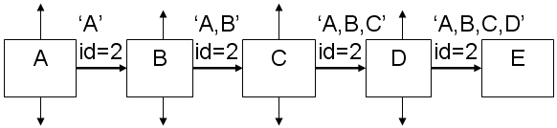
Fig. 3.1 Path discovery mechanism
If node A has in his Route Cache a route to the destination E, this route is immediately used. If not, the Route Discovery protocol is started:
- Node A (initiator) sends a multiple RREQ packet by flooding the network
- If node B has recently seen another Route Request from the same target or if the address of node B is already listed in the Route Request, Then node B discards the request!
- If node B is the target of the Route Discovery, it returns a Route Reply to the initiator. The Route Reply contains a list of the “best” path from the initiator to the target. When the initiator receives this Route Reply, it caches this route in its Route Cache for use in sending subsequent packets to this destination.
- Otherwise node B isn’t the target and it forwards the Route Request to his neighbors (except to the initiator).

3.5.2 Data routing process
The source node s discovers the best shortest path to destination through fitness function, after discovering the source node S starts transmitting data to receivers using user data gram protocol, the optimal double search routing is based on the link stability factor of nearest neighbor nodes. Path maintenance provides different mechanisms to ensure that packets can be safely transmitted from source to destination. Each path is associated with a refresh time after which a new path discovery phase is triggered. This is done to avoid path failure as the network topology may change after a certain time. Nodes may also have unanticipated behavior that may cause path failure. In this case a reactive path recovery procedure is triggered in addition to the previous mechanism, which can be seen as a hybrid path recovery.

3.5.3 Path Maintenance

In our proposed work every node is responsible for confirming that the next hop in the Source Route receives the packet. Also each packet is only forwarded once by a node (hop-by-hop routing). If a packet can’t be received by a node, it is retransmitted up to some maximum number of times until a confirmation is received from the next hop.
Only if retransmission results then in a failure, a Route Error message is sent to the initiator that can remove that Source Route from its Route Cache. So the initiator can check his Route Cache for another route to the target. If there is no route in the cache, a RouteRequest packet is broadcasted.
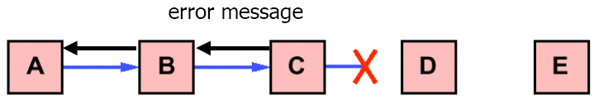
Fig. 3.2 Path Maintenance mechanism
- If node D is failure due to mobility and drops the packets.
- As soon as node receives the RouteError message, it deletes the broken-link-route from its cache. If A has another route to E, it sends the packet immediately using this new route.
- Otherwise the initiator A is starting the Route Discovery process again.
Packet Delivery Fraction (PDF):
This is the ratio of total number of packets successfully received by the destination nodes to the number of packets sent by the source nodes throughout the simulation.
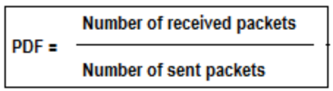
This estimate gives us an idea of how successful the protocol is in delivering packets. A high value of Packet Delivery Fraction indicates that most of the packets are being delivered to the higher layers and is a good indicator of the algorithm performance.
Average End-to-End Delay (AED):
This is defined as the average time taken by the data packets to reach the intended destinations. This include delay occurred due to different reasons like queuing delay, propagation delay, processing delay etc.
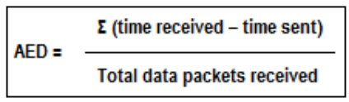
3.6 FEASIBILITY STUDY
3.6.1 Technology and system feasibility
The assessment is based on an outline design of system requirements in terms of Input, Processes, Output, Fields, Programs, and Procedures. This can be quantified in terms of volumes of data, trends, frequency of updating, etc. in order to estimate whether the new system will perform adequately or not. Technological feasibility is carried out to determine whether the company has the capability, in terms of software, hardware, personnel and expertise, to handle the completion of the project.

3.6.2 Economic feasibility
Economic analysis is the most frequently used method for evaluating the effectiveness of a new system. More commonly known as cost/benefit analysis, the procedure is to determine the benefits and savings that are expected from a candidate system and compare them with costs. If benefits outweigh costs, then the decision is made to design and implement the system. An entrepreneur must accurately weigh the cost versus benefits before taking an action.
Cost Based Study: It is important to identify cost and benefit factors, which can be categorized as follows: 1. Development costs; and 2. Operating costs. This is an analysis of the costs to be incurred in the system and the benefits derivable out of the system.
Time Based Study: This is an analysis of the time required to achieve a return on investments. The benefits derived from the system. The future value of a project is also a factor. As per the cost based study this system requires the designing and implementing environment as listed below
  - Ns-allinone
  - Cygwin
3.6.3 Legal feasibility
Determines the proposed system conflicts with legal requirements, a data processing system must comply with the local software Protection. This system satisfies all the legal requirements and it also complying with the local data protection act.

3.6.4 Operational feasibility
Is a measure of how well a proposed system solves the problems, and takes advantage of the opportunities identified during scope definition and how it satisfies the requirements identified in the requirements analysis phase of system development.This system operates well in the running environment and run as per the definition provided in the system definition.

3.6.5 Schedule feasibility
A project will fail if it takes too long to be completed before it is useful. Typically this means estimating how long the system will take to develop, and if it can be completed in a given time period using some methods like payback period. Schedule feasibility is a measure of how reasonable the project timetable is. Given our technical expertise, are the project deadlines reasonable? Some projects are initiated with specific deadlines

CHAPTER – 4
SYSTEM SPECIFICATION

4.1 HARDWARE REQUIREMENT

CPU type : Intel Pentium 4
Clock speed : 3.0 GHz
Ram size : 512 MB
Hard disk capacity : 80 GB
Monitor type : 15 Inch color monitor
Keyboard type : Internet keyboard
CD -drive type : 52xmax

4.2 SOFTWARE REQUIREMENT

Operating system : Linux, windows
Simulation Tool : Cygwin-NS-2
Documentation : Ms-Office

CHAPTER – 5
SOFTWARE DESCRIPTION

5.1 LINUX
5.1.1 Introduction:
It is a modern very stable multi-user multitasking environment with an inexpensive PC or hardware, at no (or almost no) monetary cost for the software. Linux is VERY standard--it is essentially a POSIX compliant UNIX. Linux includes all the UNIX standard tools and utilities. It is known as advanced graphical user interface. Linux uses a standard, network-transparent X-windowing system with a "window manager".

5.1.2 BENEFITS
Low cost:
There is no need to spend time and money to obtain licenses since Linux and much of its software comes with the GNU General Public License. It is able to start working immediately without worrying that your software may stop working anytime because the free trial version expires. Additionally, there are large repositories from which you can freely download high quality software for almost any task you can think of.
Stability:
Linux doesn’t need to be rebooted periodically to maintain performance levels. It doesn’t freeze up or slow down over time due to memory leaks and such. Continuous up-times of hundreds of days (up to a year or more) are not uncommon.

Performance:
Linux provides persistent high performance on workstations and on networks. It can handle unusually large numbers of users simultaneously, and can make old computers sufficiently responsive to be useful again.

Network friendliness:
Linux was developed by a group of programmers over the Internet and has therefore strong support for network functionality; client and server systems can be easily set up on any computer running Linux. It can perform tasks such as network backups faster and more reliably than alternative systems.
Flexibility:
Linux can be used for high performance server applications, desktop applications, and embedded systems. You can save disk space by only installing the components needed for a particular use. You can restrict the use of specific computers by installing for example only selected office applications instead of the whole suite.

Compatibility:
It runs all common UNIX software packages and can process all common file formats.

Choice:
The large number of Linux distributions gives you a choice. Each distribution is developed and supported by a different organization. You can pick the one you like best; the core functionalities are the same; most software runs on most distributions.

Fast and easy installation:
Most Linux distributions come with user-friendly installation and setup programs. Popular Linux distributions come with tools that make installation of additional software very user friendly as well.

Full use of hard disk:
Linux continues work well even when the hard disk is almost full.

Multitasking:
Linux is designed to do many things at the same time; e.g., a large printing job in the background won’t slow down your other work.

Security:
Linux is one of the most secure operating systems. “Walls” and flexible file access permission systems prevent access by unwanted visitors or viruses. Linux users have to option to select and safely download software, free of charge, from online repositories containing thousands of high quality packages. No purchase transactions requiring credit card numbers or other sensitive personal information are necessary.

Open Source:
If software is developed which requires knowledge or modification of the operating system code, Linux’s source code is at your fingertips. Most Linux applications are Open Source as well.

5.2 NETWORK SIMULATOR-2
After setting up the platform, software named ns2 was set up on it which was used for all the analysis and simulation work apart from other tools used. Ns2 is the de facto standard for network simulation. Its behavior is highly trusted within the networking community. It is developed at ISI, California, and is supported by the DARPA and NSF. Ns2 is an object oriented simulator, written in C++, with an OTcl interpreter as a frontend. This means that most of the simulation scripts are created in Tcl. If the components have to be developed for ns2, then both Tcl and C++ have to be used. Ns2 uses two languages because any network simulator, in general, has two different kinds of things it needs to do. On the one hand, detailed simulations of protocols require a systems programming language which can efficiently manipulate bytes, packet headers, and implement algorithms that run over large data sets. For these tasks run-time speed is important and turn-around time (run simulation, find bug, fix bug, recompile, re-run) is less important. On the other hand, a large part of network research involves slightly varying parameters or configurations, or quickly exploring a number of scenarios. In these cases, iteration time (change the model and re-run) is more important. Since configuration runs once (at the beginning of the simulation), run-time of this part of the task is less important.

5.2.1 STRUCTURE OF NS-2
- Create the event scheduler
- Turn on tracing
- Create network
- Setup routing
- Insert errors
- Create transport connection
- Create traffic
- Transmit application-level data
5.2.2 FUNCTIONALITIES OF NS-allione2.28:
C++/OTcl Linkage
Root of ns-2 object hierarchy
Bind (): link variable values between
TclObject
C++ and OTcl
Command (): link OTcl methods to C++ implementations
TclClass
Create an OTcl object, and create a linkage between the OTcl object and C++ Object
Tcl C++
Methods to access Tcl interpreter
TclCommand
Standalone global commands
EmbeddedTcl
ns script initialization

5.2.3 HOW TO START TCL SCRIPTS
We can write were Tcl scripts in any text editor like Joe or emacs. First of all, we need to create a simulator object. This is done with the command set ns [new Simulator] Now we open a file for writing that is going to be used for the nam trace data. Set nf [open out.nam w] $ns namtrace-all $nf The first line opens the file 'out.nam' for writing and gives it the file handle 'nf'. In the second line we tell the simulator object that we created above to write all simulation data that is going to be relevant for nam into this file. The next step is to add a 'finish' procedure that closes the trace file and starts nam.

5.3 NETWORK COMPONENTS
The root of the hierarchy is the TclObject class that is the superclass of all OTcl library objects (scheduler, network components, timers and the other objects including NAM related ones). As an ancestor class of TclObject, NsObject class is the superclass of all basic network component objects that handle packets, which may compose compound network objects such as nodes and links. The basic network components are further divided into two subclasses, Connector and Classifier, based on the number of the possible output data paths. The basic network objects that have only one output data path are under the Connector class, and switching objects that have possible multiple output data paths are under the Classifier class.

5.3.1 PACKET
A NS packet is composed of a stack of headers, and an optional data space. A packet header format is initialized when a Simulator object is created, where a stack of all registered (or possibly useable) headers, such as the common header that is commonly used by any objects as needed, IP header, TCP header, RTP header (UDP uses RTP header) and trace header, is defined, and the offset of each header in the stack is recorded. What this means is that whether or not a specific header is used, a stack composed of all registered headers is created when a packet is allocated by an agent, and a network object can access any header in the stack of a packet it processes using the corresponding offset value.

5.3.2 STARTING NAM
NAM is a Tcl/TK based animation tool for viewing network simulation traces and real world packet trace data. The first step to use NAM is to produce the trace file. The trace file should contain topology information, e.g., nodes, links, as well as packet traces. Usually, the trace file is generated by ns2. During ns2 emulation, user can produce topology configurations, layout information, and packet traces using tracing events in ns2. When the trace file is generated, it is ready to be animated by NAM. Upon startup, NAM will read the trace file, create topology, pop up a window, do layout if necessary and then pause at the time of the first packet in the trace file. Through its user interface, NAM provides control over many aspects of animation.

5.3.3 TRACE GRAPH
Trace graph is a free tool for analyzing the trace files generated by ns2. Trace graph can support any trace format if converted to its own or ns2 trace format. Trace graph runs under Windows, Linux, and UNIX and MAC OS systems.
Some of the program features are as follows:
- 238 2D graphs: Tracegraph supports drawing 238 different graphs depending upon different parameters in 2 Dimensional areas.
- 12 3D graphs: Tracegraph supports 12 graphs in 3 Dimensions.
- Delays, jitter, processing times, round trip times, throughput graphs and statistics can be plotted with the help of Tracegraph. These are described below:
- Delay: This is the delay encountered between the sending and receiving of the packet.
- Jitter: This is the unwanted variation in the output.
- Processing Time: The time it takes for a node to process the input.
- Round Trip Time: The time required for a signal pulse to travel from a specific source to a specific destination and back again.
- Whole network, link and node graphs and statistics.
- All the results can be saved to text files, graphs can also be saved as jpeg and tiff.
- Any graph saved in text file with 2 or 3 columns can be plotted.
- Script files processing to do the analysis automatically.
The program does have some disadvantages though, such as it hangs or takes a very long time while trying to open large trace files. Also it sometimes hangs after displaying the graph in 3D. The reason why this tool was used in the simulation work is that there are not too many graph plotting tools available in the market.

5.3.4 SCENARIO FILE
As cbr file is used to store the traffic connections, similarly scenario file is used to store the initial position of the nodes and movement of nodes at different times and their speed, etc. Since it will be difficult to manually give initial position, movement of the nodes and their speed for each movement at different times we use a random file generator here also. The node movement generator is available under /indep-utils/cmu-scen-gen/setdest/ directory. It is available under the name “setdest”, which is an exe file. This file is run with certain arguments to create the scenario file.
The arguments are:
- Number of nodes
- Pause time
- Maximum speed
- Simulation time
- X-axis dimension
- Y-axis dimension

5.3.5 LINK
A link is another major compound object in NS. When a user creates a link using a duplex-link member function of a Simulator object, two simplex links in both directions are created. One thing to note is that an output queue of a node is actually implemented as a part of simplex link object. Packets dequeued from a queue are passed to the Delay object that simulates the link delay, and packets dropped at a queue are sent to a Null Agent and are freed there. Finally, the TTL object calculates Time to live parameters for each packet received and updates the TTL field of the packet.

5.3.6 STARTING NS
NS starts with the command ns (assuming that we are in the directory with the ns executable, or that were path points to that directory), where is the name of a Tcl script file which defines the simulation scenario (i.e. the topology and the events). We could also just start ns without any arguments and enter the Tcl commands in the Tcl shell, but that is definitely less comfortable. Everything else depends on the Tcl script. The script might create some output, it might write a trace file or it might start nam to visualize the simulation.

5.4 PROTOCOLS
A Heterogeneous Network (MANET) is a kind of wireless ad-hoc network, and is a self configuring network of mobile routers (and associated hosts) connected by wireless links the union of which forms an arbitrary topology. The routers are free to move randomly and organize themselves arbitrarily, thus the network's wireless topology may change rapidly and unpredictably. Such a network may operate in a standalone fashion, or may be connected to the larger Internet. There are various routing protocols available for MANETs. The most popular ones are DSR, AODV and DSDV. In this thesis, an attempt has been made to compare these three protocols on the performance basis under different environments. The comparison has been done under two protocols namely UDP and TCP. The tools used for the simulation are NS2 which is the main simulator, NAM (Network Animator) and Tracegraph which is used for preparing the graphs from the trace files. The results presented in this thesis work clearly indicate that the different protocols behave differently under different environments. The results also illustrate the important characteristics of different protocols based on their performance and thus suggest some improvements in the respective protocols. Protocol names: MANET, AODV, DSR, DSDV, NS2, NAM, UDP, TCP, Tracegraph.

5.5 ROUTING ALGORITHMS
Most QoS routing algorithms represent an extension of existing classic best-effort routing algorithms. Many routing protocols have been developed which support establishing and maintaining multi-hop routes between nodes in MANETs. These algorithms can be classified into two different categories: on-demand (reactive) such as DSR, AODV, and TORA, and table-driven (proactive) such as Destination Sequenced Distance Vector protocol (DSDV). In the on-demand protocols, routes are discovered between a source and a destination only when the need arises to send data. This provides a reduced overhead of communication and scalability. In the table-driven protocols, routing tables which contain routing information between all nodes are generated and maintained continuously regardless of the need of any given node to communicate at that time. With this approach, the latency for route acquisition is relatively small, which might be necessary for certain applications, but the cost of communications overhead incurred in the continued update of information for routes which might not be used for a long time if at all is too high.

5.5.1 DSR- DYNAMIC SOURCE ROUTING PROTOCOL
DSR is one of the most well known routing algorithms for ad hoc wireless networks. It was originally developed by Johnson, Maltz, and Broch. DSR uses source routing, which allows packet routing to be loop free. It increases its efficiency by allowing nodes that are either forwarding route discovery requests or overhearing packets through promiscuous listening mode to cache the routing information for future use. DSR is also on demand, which reduces the bandwidth use especially in situations where the mobility is low. It is a simple and efficient routing protocol for use in ad hoc networks. It has two important phases, route discovery and route maintenance.

5.5.2 AODV - THE AD HOC ON-DEMAND DISTANCE-VECTOR PROTOCOL
AODV is another routing algorithm used in ad hoc networks. Unlike DSR, it does not use source routing, but like DSR it is on-demand. In AODV, each node maintains a routing table which is used to store destination and next hop IP addresses as well as destination sequence numbers. Each entry in the routing table has a destination address, next hop, precursor nodes list, lifetime, and distance to destination.

INTERESTING CONCEPTS OF AODV
The concepts of AODV that make it desirable for MANETs with limited bandwidth include the following:
- Minimal space complexity: The algorithm makes sure that the nodes that are not in the active path do not maintain information about this route. After a node receives the RREQ and sets a reverse path in its routing table and propagates the RREQ to its neighbors, if it does not receive any RREP from its neighbors for this request, it deletes the routing info that it has recorded.
- Simple: It is simple with each node behaving as a router, maintaining a simple routing table, and the source node initiating path discovery request, making the network self-starting.
- Most effective routing info: After propagating an RREP, if a node finds receives an RREP with smaller hop-count, it updates its routing info with this better path and propagates it.
- Most current routing info: The route info is obtained on demand. Also, after propagating an RREP, if a node finds receives an RREP with greater destination sequence number, it updates its routing info with this latest path and propagates it.
- Highly Scalable: The algorithm is highly scalable because of the minimum space complexity and broadcasts avoided when it compared with DSDV

ADVANCED USES OF AODV
- Because of its reactive nature, AODV can handle highly dynamic behavior of Vehicle Ad-hoc networks.
- Used for both unicasts and multicasts using the ’J’ (Join multicast group) flag in the packets.

LIMITATIONS/DISADVANTAGES OF AODV
- Requirement on broadcast medium: The algorithm expects/requires that the nodes in the broadcast medium can detect each others’ broadcasts.
- Overhead on the bandwidth: Overhead on bandwidth will be occurred com- pared to DSR, when an RREQ travels from node to node in the process of discovering the route info on demand, it sets up the reverse path in itself with the addresses of all the nodes through which it is passing and it carries all this info all its way.
- No reuse of routing info: AODV lacks an efficient route maintenance technique. The routing info is always obtained on demand, including for common cause traffic.
- It is vulnerable to misuse: The messages can be misused for insider attacks including route disruption, route invasion, node isolation, and resource consumption.
- High route discovery latency: AODV is a reactive routing protocol. This means that AODV does not discover a route until a flow is initiated. This route discovery latency result can be high in large-scale mesh networks.

5.5.3 DSDV - THE DESTINATION SEQUENCED DISTANCE VECTOR PROTOCOL
DSDV is one of the most well known table-driven routing algorithms for MANETs. It is a distance vector protocol. In distance vector protocols, every node i maintains for each destination x a set of distances {dij(x)} for each node j that is a neighbor of i. Node i treats neighbor k as a next hop for a packet destined to x if dik(x) equals minj{dij(x)}. The succession of next hops chosen in this manner leads to x along the shortest path. In order to keep the distance estimates up to date, each node monitors the cost of its outgoing links and periodically broadcasts to all of its neighbors its current estimate of the shortest distance to every other node in the network. The distance vector which is periodically broadcasted contains one entry for each node in the network which includes the distance from the advertising node to the destination. The distance vector algorithm described above is a classical Distributed Bellman-Ford (DBF) algorithm.

ADVANTAGES OF DSDV
- DSDV protocol guarantees loop free paths.
- Count to infinity problem is reduced in DSDV. We can avoid extra traffic with incremental updates instead of full dump updates.
- Path Selection: DSDV maintains only the best path instead of maintaining multiple paths to every destination. With this, the amount of space in routing table is reduced.

CHAPTER-6
SYSTEM DESIGN
6.1 INPUT DESIGN
Input Screen must be design in such a way to give an easy navigation throughout the screen without the violation of the input validation.
Input design is the process of converting the user-originated data into a computer-based format. Inaccurate input data are the most common cause of error in data processing. The goal of an input data are collected and organized into a group and error free. Input data are collected and organized into a group of similar data. Once identified, appropriated input media are selected for processing.
The design was done with six major objectives in mind
- Effectiveness
- Accuracy
- Ease of Use
- Consistency
- Simplicity
- Attractiveness

6.2 OUTPUT DESIGN
Designing computer output should proceed in an organized, well throughout manner; the right output must be developed while ensuring that each output element is designed so that candidates will find the system easy to use effectively. The term output refers to any effect produced by a system whether displayed or executed. When we design an output we must identify the specific output that is needed to meet the system. The usefulness of the new system is evaluated on the basis of their output. The output from the computer systems is required primarily to communicate the results of processing to users.
An output generally refers to the result that is generated by the system. An application is successful only when it can produce efficient and effective reports. The reports generated must be useful for the management and for the future reference

CHAPTER-7
SYSTEM TESTING
System testing is the stage of implementation, which is aimed at ensuring that the system works accurately and efficiently before live operation commences. Testing is vital to the success of the system. An elaborate testing of data is prepared and the system is tested using this test data while testing errors are noted and the corrections are made. The users are trained to operate the developed system. Both hardware and software securities are made to run the developed system successfully in future.

7.1 TESTING STEPS
- Unit Testing
- Integration Testing
- Validation Testing
- Output Testing
- User Acceptance Testing
7.2 UNIT TESTING
Unit testing focuses verification efforts on the smallest unit of software design and the module. This is also known as “Module Testing”. The modules are tested separately. This testing is carried out during programming stage itself. In this testing step each Module is found to be working satisfactorily as regard to the expected output from the module.

7.3 INTEGRATION TESTING
Integration testing is a systematic technique for constructing tests to uncover errors associated within the interface. In this project, all the modules are combined, and then the entire Program is tested as a whole. Thus in the integration testing step, all the errors uncovered are corrected for the next testing steps.
7.4 VALIDATION TESTING
Validation testing is the testing where requirements are established as a part of software requirement analysis is validated against the software that has been constructed. This test provides the final assurance that the software meets all functional, behavioral and performance requirements .The errors, which are uncovered during integration testing, are corrected during this phase.
7.5 OUTPUT TESTING
After performing the validation testing, the next step is output testing of the proposed system since no system could be useful if it does not produce the required output in the specific format. The Output generated or displayed by the system under consideration is tested asking the users about the format required by then. Here, the output is considered into two ways: one is on the screen and the other is in a printed format.
The output format on the screen is found to be correct as the format designed according to the user needs.

7.6 USER ACCEPTANCE TESTING
The testing of the software began along with coding. Since the design was fully object-oriented, first the interfaces were developed and tested. Then unit testing was done for every module in the software for various inputs, such that each line of code is at least once executed User acceptance of a system is the key factor for the success of any system.

CHAPTER – 8
PROJECT DESCRIPTION

8.1 MODULE DESCRIPTION
- Creation of mobile nodes
- Finding two optimal routes
- Performance Analysis
8.1.1 Creation of mobile nodes
This module is developed to node creation and more than 20 mobile nodes placed particular distance. Wireless mobile nodes are placed intermediate area. Each node knows its location relative to the neighbors.
8.1.2 Finding Two Optimal Routes
This is the form of dual path search process to discover the best path for routing under mobility factor. So source node broadcast a dual RREQ route request packet to discover the best path, based on the RREQ the destination node replies the RREP route reply message to the to source node.

8.1.3 Performance Analysis
After receiving the multiple route reply from destination, the source node s discovers the best shortest path to the destination based on the fitness function, the fitness function is based on the minimum hop count, nearest distance range and link stability of the mobile nodes. Based on this selected path the packets are transmitted to destination.
Due to the mobility nature of the network, the path failure or node failure is frequent and common issues. So in our scenario, the intermediate node fails and drops the packets, through our proposed optimal search based adhoc routing protocol, the packets are retransmitted in alternate path, as soon as the intermediate node fails, as a result the packet loss and delay is minimized.
Graph is an essential part of displaying a result, so we plot a graph to show a various result comparison with packets, throughput, energy efficient and etc.
8.2 RELATED WORK
The objective of this work is to create algorithms to obtain the two routes that have the best joint availability in a telecommunication network with a semi-mesh configuration. These two routes connect a source node to a destination node, the last one being a Remote Front End (RFE) Concentrator and they are alternate paths in a standby configuration for an important service whose failure condition can be modeled as a logical AND gate of the condition of a two path parallel circuit. The service keeps on working while at least one of the paths keeps on working, and the service comes down only if both paths come down.
A path is a concatenation of several links and nodes. One link or node down is necessary and sufficient for the path being down. One path can be down as a consequence of other causes different from the failure of a link, for instance, a power failure in the installation at a node. So we propose an algorithm which will select two paths with maximum energy.

8.3 METHODOLOGIES
8.3.1 Working Principles:
By using physical diversity, usually by establishing at least two alternate routes (between each node and the mobile adhoc network station) with the minimum number of shared elements or no shared elements.
In this projects, network availability is measured in terms of the connectivity of its nodes, i.e., the average time fraction that each node has a functioning connection with the selected destination. Other issues, as the delay or the throughput of the available communication links are assumed to be less critical than the connectivity, which is a reasonable assumption in mobile adhoc networks, where the connection loss, which implies the inability to communicate network failures to control stations, is much more critical than the quality of the communication links.

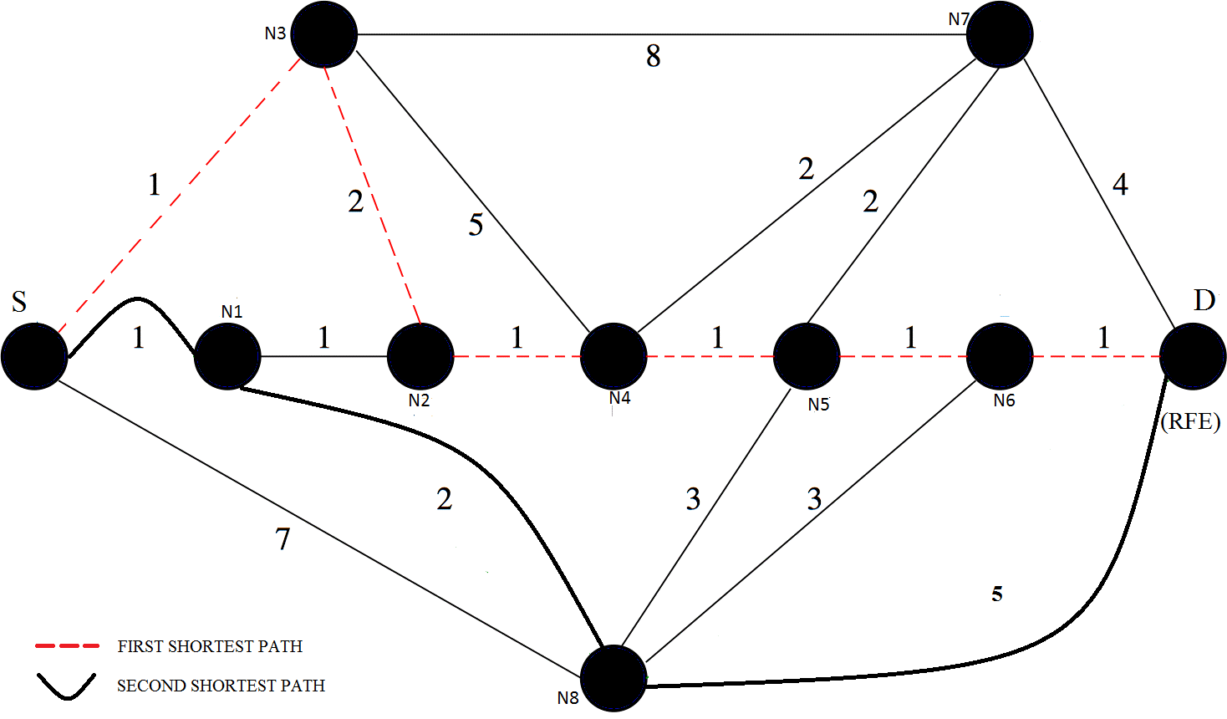

Fig. 8.1. Double path selection problem. There are two shortest paths from source node (S) to the RFE destination node (D): S-N3-N2-N4-N5-N6-D and S-N1-N8-D. The goal is to select the pair of paths maximizing the connectivity of node S and energy efficiency. This must be done for every node in the network.

The algorithm focuses on the connectivity optimization and energy efficiency. Algorithms for double-path search that optimize additive metrics on weighted graphs have been proposed in the literature, which are computationally efficient. However, the use of additive metrics is suboptimal, and may degrade the network availability.

The energy is calculated by the sum of ideal energy, transmission energy and residual energy. E_{total energy} =E_{idle energy} + E_{Transmission energy} + E_{Received energy}
The path which is having maximum energy is first priority then the second path is having second priority. Comparing the both path energies, select the maximum energy path to obtain energy efficiency in double route search[18].
E_{p}=Max (Ep_{i}, Ep_{j}) here i and j are paths

8.3.2 Proposed Algorithm – ODRM
Steps
- Find the shortest path from S to D with the modified Dijkstra algorithm
- Replace each edge of the shortest path by a single arc directed towards the source vertex
- Make the length of each of the above arcs negative
- Find the shortest path from S to D in the modified graph with the modified Dijkstra algorithm
- Transform to the original graph, and erase any interlacing edges of the two paths found
- Group the remaining edges to obtain the shortest pair of edge-disjoint paths

Input
G = (V, E)
d(n) – the distance of vertex n from source vertex S , n∈V and S∈V
//it’s the sum of arcs in a possible path from vertex S to vertex n.
d(S)=0;
P(n) – the predecessor of vertex I on the same path.
D – the destination vertex.

We assume that each node has two mobile network paths to its RFE, i.e., even though there may be many paths connecting each node with its RFE, we assume that only two of them can be used by the mobile adhoc network. If the manet paths are fully disjoint (i.e. they do not share any node and any link), then node connectivity can be determined as follows.

The following steps are the mathematical notation for the proposed algorithm.

Step 1.
Start with d(S)=0,
d(n) = l (Sn), if n∈ΓS;
= ∞, otherwise (∞ is a large number defined below);
Γn ≡ set of neighbor vertices of vertex a,
l(nb) = length of arc from vertex a to vertex b.
Assign A = V-{S}, where V is the set of vertices in the given graph.
Assign P(n) = S, ∀n∈A.

Step 2.
a) Find b∈A such that d(b) = min d(a), a∈A.
b) Set A = A – {b}.
c) If b = Z (the destination vertex), END; otherwise go to Step3.

Step 3.
∀a∈Γb, if d(b)+l(ab)<d(a),
a) set d(a) = d(b) + l(ab), P(a) = b.
b) A = A ∪{a}
Go to Step 2.

This equation states an additive unavailability model, where the impact of adding a new node gives an unavailability increment that depends only on the unavailability of the added node or link.

The Bhandari algorithm involves two steps of the Dijkstra algorithm, and can be extended to the case where no disjoint paths exist by searching the minimization of the total cost. It is computationally efficient, but the replacement of a multiplicative cost optimization of an additive cost may be sub optimal. If the connectivity loss is large, the availability of the path pairs is substantially different. Because the connectivity is a nonlinear function of the unavailability, the optimization of an additive cost is sub- optimal, and even in simple networks the connectivity loss of the pair of paths obtained by the Bhandari algorithm can be several orders of magnitude higher than the optimal value.

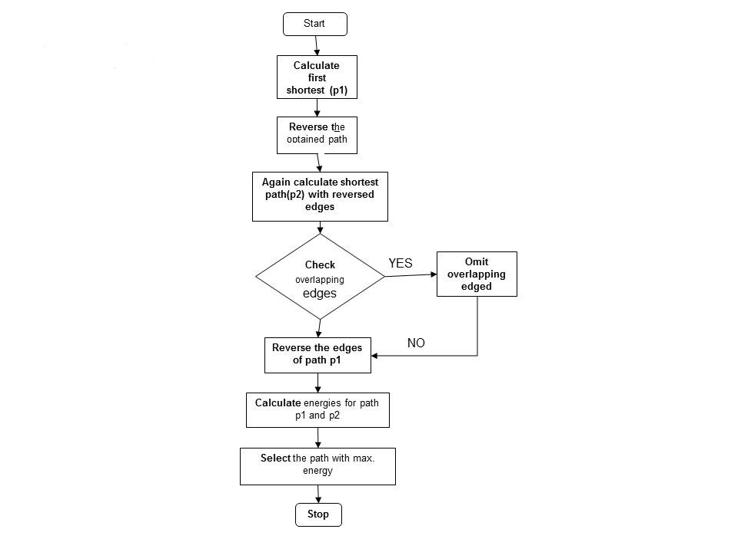
Fig 8.2 Flow chart for ODRM algorithm

In heterogeneous networks, with a high degree of variability in the link availability, connectivity optimization could improve the connectivity of some nodes whose paths are not fully disjoint, or may have some links with low availability.

8.3.3 Energy Efficiency
The optimization process may stop when the probability of finding a better pair of paths is low enough.
The algorithm proceeds by exploring over a set of possible paths, which are progressively built by adding a new hop, and computing the availability of all the possible paths. The sequence of steps is as follows.

Consider the following two shortest paths P1 and P2.
P1= {n0,n1,n3,………..}
P2= {n0,n2,n4,………..}
R_{p} = {P_{i}, P_{j}}
Then the energy is calculated by the following method.
En_{i} =E_{idle} + E_{TX} + E_{RX}
Then the energy of i^{th} path is calculated by following method.
Ep_{i}
After finding individual path energies then compare both energies to achieve energy efficiency in manet.
EE_{P} = max(Ep_{i} , Ep_{j} )
Finally, the best energy efficiency path is selected from both the alternative paths.

CHAPTER – 9
SYSTEM IMPLEMENTATION

SCREEN SHOTS:
Mobile nodes creation:
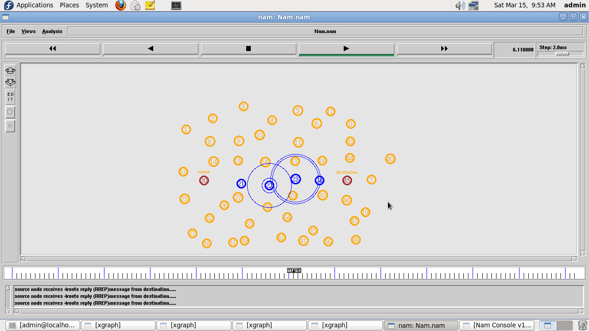
Here the mobile nodes are created in a random manner. Wireless mobile nodes are placed intermediate area. Each node knows its location relative to the neighbors. Here source node broadcast a dual RREQ route request packet to discover the best path, based on the RREQ the destination node replies the RREP route reply message to the to source node.By this shortest path is established between source and destination .

Transmission in First path:
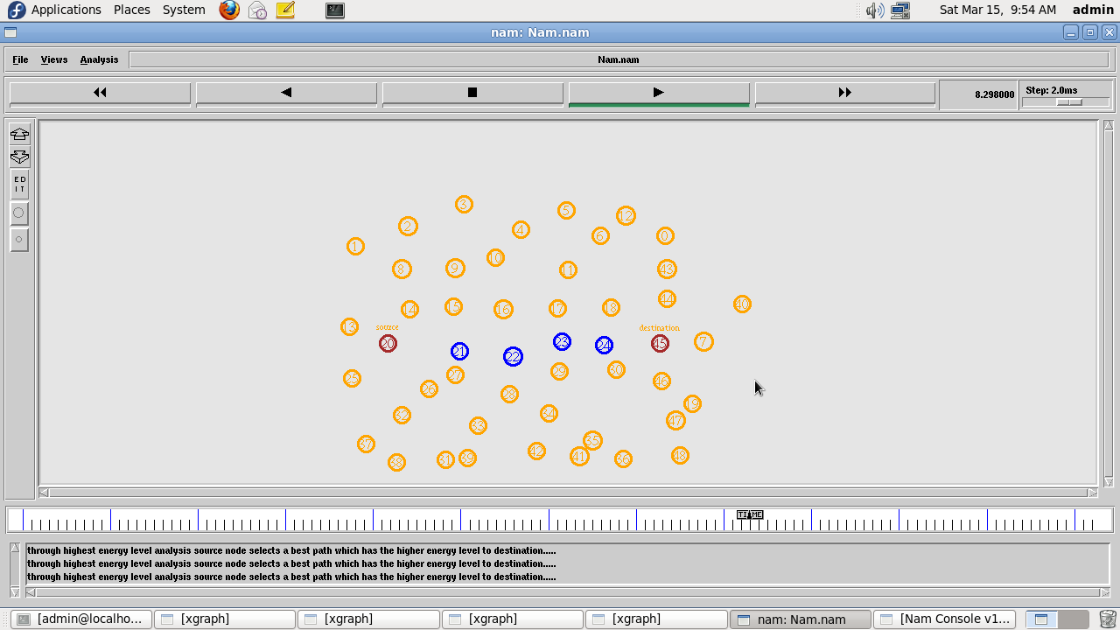
The source node s discovers the best shortest path to the destination based on the fitness function, the fitness function is based on the minimum hop count, nearest distance range and link stability of the mobile nodes. Based on this selected path the packets are transmitted to destination.

Selection of Alternative disjoint path after failure of one node in first path:
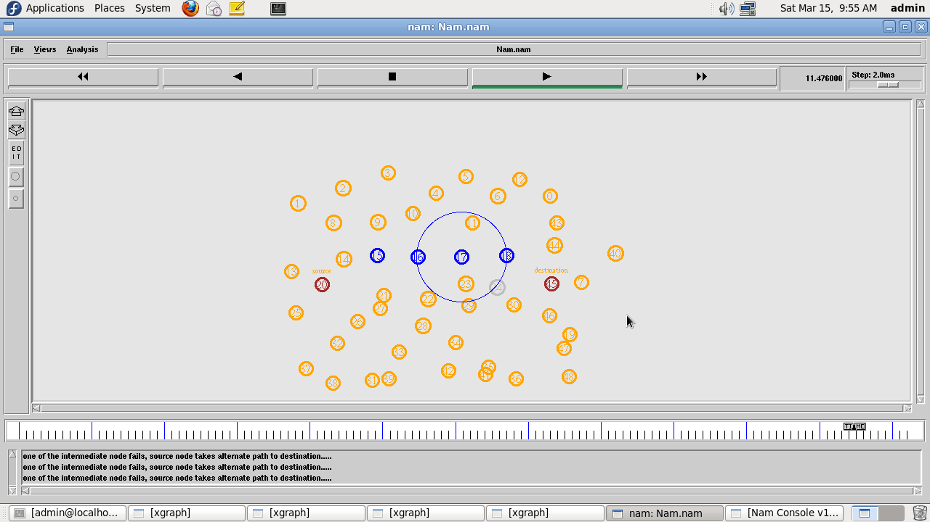
.
Here , due to the failure of one of the node in the first path, the network automatically selects the second from the established double route for the transmission.

CHAPTER – 10
RESULT
Performance Analysis :
Packet Delivery Ratio:
Packet delivery ratio is defined as the ratio of data packets received by the destinations to those generated by the sources. The below graph shows a comparison between the routing protocols on the basis of packet delivery ration as a function. The proposed ODRM protocol provides high PDR compared with AODV and CBRP.

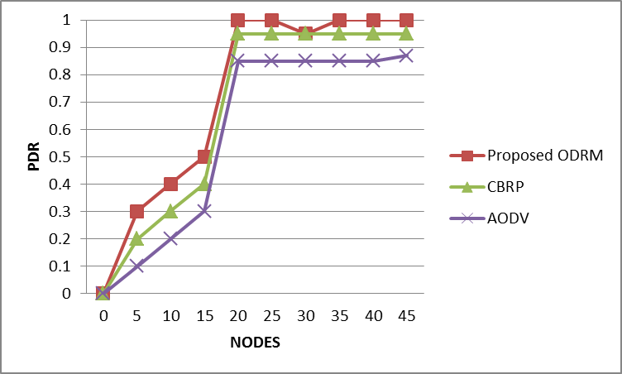

Energy level in all Paths:
The total energy is calculated by the sum of transmission energy and residual energy. Each nodes losses the energy for transmission. Here the path1 has high energy through the transmission. From this table the proposed ODRM protocol is less energy consumption compared with AODV and CBRP.
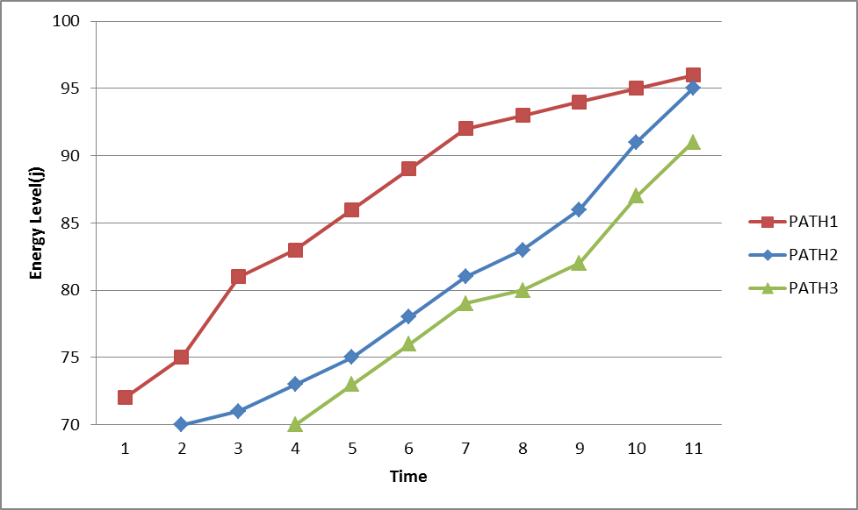

Energy Consumption Level:
The below graph shows the graphs for Energy consumption Vs simulation time. From these graphs we see that the AODV has spent more energy in networks. Then the CBRP has spent less energy then AODV because of forming of Clusters. The proposed ODRM provides less energy than others.
Table 10.1 Energy consumption table
Protocols | Energy consumption(mj)
AODV | 43.8
CBRP | 43.7
Proposed ODRM | 40.5
The above table shows that the amount of energy consumption in the above three protocols.

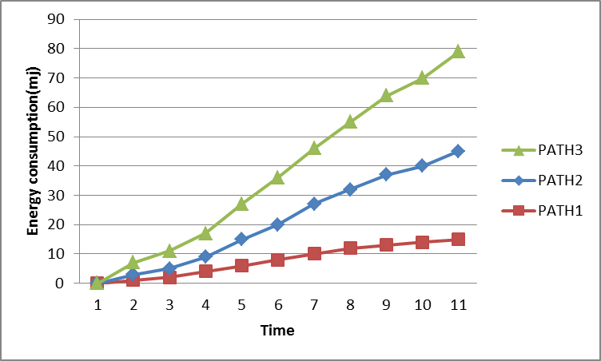

Performance Analysis – Throughput:
It is defined as the total number of packets delivered over the total simulation time. The throughput comparison shows that the three algorithms performance margins are very close under traffic load. The below graph shows the throughput of CBRP, AODV and the proposed ODRM protocol. The ODRM protocol has high throughput compared with ODRM and AODV.
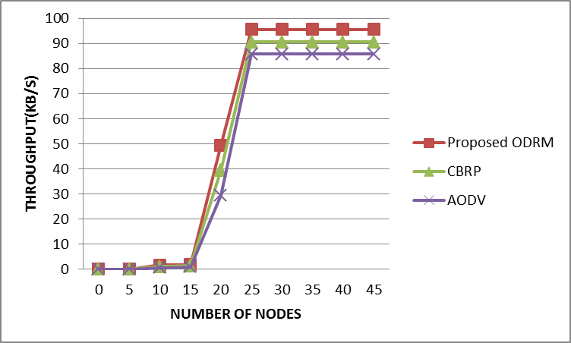
CHAPTER – 11
CONCLUSION

The results obtained were mainly coherent with intuition: availability improvement is huge when having two paths in comparison with just one, and even a precarious second path increases the availability by several magnitude orders. Another result coherent with experience was that if one link is shared between the two paths, this makes the availability decrease about a magnitude order, which clearly represents a situation to be avoided. Special focus has been paid to the comparison between connectivity and disjoint path optimization. Connectivity algorithms have been specifically developed to find the best pair of routes in a transmission network similar to the one described, not considering the additive approximation of unavailability.
Energy of the two alternative routes are calculated. Route which has maximum energy is selected for transmission in order to increase the energy efficiency. Disjoint Path optimization based on Bhandari algorithm is a general purpose algorithm to be applied in graphs with an additive cost where its performance is unsurpassable in practice.
In summary, the proposed algorithms can be considered as useful tools to find the two best routes in a MANET network, as proposed when the availability of some links is expected to be low. One particular application could be as a cost-benefit analysis investment tool, which could quantify the increased availability for an investment in an additional link is going to produce in the network. Moreover, if additional information about the network behavior can be available.

CHAPTER – 12
REFERENCES

- P. Manickam et “Performance Comparisons of Routing Protocols in mobile ad hoc networks”,International Journal of Wireless & Mobile Networks (IJWMN) Vol. 3, No. 1, February 2011.

- Shiva Prakash et “A review of Energy Efficient Routing Protocols for Mobile Ad Hoc Wireless Networks”, International Journal of Computer Information Systems, Vol. 1, No. 4, 2010.

- Sankalp Bahadur Singh and Asha Ambhaikar “Optimization of Routing Protocol in MANET using GA”, International Journal of Science and Research (IJSR).

- Marzio Marseguerra, Enrico Zio, Luca Podoﬁllini, and David W. Coit, “Optimal Design of Reliable Network Systems in Presence of Uncertainty”, IEEE Transactions on Reliability, vol. 54, no. 2, 2005
- M. Younis and S.Z. Ozer, “Wireless ad-hoc networks: Technologies and challenges,” Wireless commun. Mobile computing, vol. 6, no. 7, pp. 889-992, Nov. 2006
- Chih-Ya Shen, De-Nian Yang, and Ming-Syan Chen, “Collaborative and Distributed Search System with Mobile Devices”, IEEE transactions on mobile computing, vol. 11, no. 10, october 2012.
- Wenjia Li and Anupam Joshi, et al., “Security Issues in Mobile Ad Hoc Networks” Computer Commun., vol.30, no.9, pp. 2129-2148, June 2007
- Valentina Timcenko, Mirjana Stojanovic and Slavica Bostjancic Rakas,”MANET Routing Protocols vs. Mobility Models: Performance Analysis and Comparison”, Proceedings of the 9th WSEAS International Conference on Applied Informatics And Communications, 2009
- Azadeh Soltani, M.R. Akbarzadeh-T, M. Naghibzadeh, “Helping ants for adaptive network routing”, Journal of the Franklin Institute, Elsevier, pp:389-403,2006
- Rutvij H. Jhaveri, Jatin D. Parmar and Bhavin I. Shah, “MANET Routing Protocols and Wormhole Attack against AODV”, IJCSNS International Journal of Computer Science and Network Security, VOL.10 No.4, April 2010
- Sangeeta Biswal, Suneeta Mohanty and Dambarudhar Seth, “Study of DSR Routing Protocol in Mobile Adhoc Network”, International Conference on Information and Network Technology, 2011
- N Vetrivelan and Dr. A V Reddy, “Performance Analysis of Three Routing Protocols for Varying MANET Size”, Proceedings of the International MultiConference of Engineers and Computer Scientists, vol 2, 2008

- Marzio Marseguerra, Enrico Zio, Luca Podoﬁllini, and David W. Coit, “Optimal Design of Reliable Network Systems in Presence of Uncertainty,” IEEE TRANSACTIONS ON RELIABILITY, VOL. 54, NO. 2, JUNE 2005

- R. Mohan, C. Rajan and Dr. N. Shanthi , “A Stable Mobility Model Evaluation Strategy for MANET Routing Protocols”, International Journal of Advanced Research in Computer Science and Software Engineering, Vol. 2, DEC 2012

- Xiaoyan Wei, “Comparative Analysis of Mobile Ad Hoc Network Routing Protocols Simulation”, Proceedings of the 2nd International Symposium on Computer, Communication, Control and Automation , 2013

- Suman Banik, Bibhash Roy, Parthi Dey, Nabendu Chaki, Sugata Sanyal “QoS Routing using OLSR with Optimization for Flooding” IJICT, Volume , Auguest 2011. ISSN-2223-4985

- Sung-Ju Lee, Julian Hsu, Russell Hayashida, Mario Gerla and Rajive Bagrodia, “Selecting a routing strategy for your ad hoc network”, Computer Communications 26 , 2003

- Chansu Yu, Ben Lee and Hee Yong Youn ,”Energy Efficient Routing Protocols for Mobile Ad Hoc Networks”, Cleveland State University, EFFRD Grant No. 0210-0630-10

- Mr. Sourabh Pandey, and Mr. Rajender Singh Yadav, “Energy Efficient Location based Routing Using DREAM Algorithm for MANET”, IOSR Journal of Engineering (IOSRJEN) Vol.3, 2013

- Vijay Kumar and Bharat Bhushan, “Analytical Evaluation Of Protocols AODV And DSR”, Jmacademy Of It &Management, 2011

- S. Baskaran and K. Tamizharasu,”An Efficient Multi-Constrained Feasible Path Selection For Manet”, International Journal of Internet Computing ISSN No: 2231 – 6965, VOL- 1, ISS- 4 2012

- Srinivas Sethi and Siba K.Udgata, “The Efficient Ant Routing Protocol for MANET”, International Journal on Computer Science and Engineering Vol. 02, No. 07, 2010

- Mukesh Kumar, Rahul Rishi and D.K. Madan, “Comparative Analysis of CBRP, DSR, AODV Routing Protocol in MANET”, International Journal on Computer Science and Engineering Vol. 02, No. 09, 2010

- Hongbo Zhou , Matt W. Mutka and Lionel M. Ni, “IP Address Handoff in the MANET”, IEEE INFOCOM 2004

- Chao Gui and Prasant Mohapatra, “Scalable Multicasting in Mobile Ad Hoc Networks”, IEEE INFOCOM 2004
- Nikhil Bansal and Zhen Liu, “Capacity, Delay and Mobility in Wireless Ad-Hoc Networks”, IEEE INFOCOM 2003

- Sencun Zhu, Shouhuai Xu ,Sanjeev Setia and Sushil Jajodia “Establishing Pairwise Keys for Secure Communication in Ad Hoc Networks: A Probabilistic Approach”, Proceedings of the 11th IEEE International Conference on Network Protocols 2003

- Zhenqiang Ye, Srikanth V. Krishnamurthy and Satish K. Tripathi “A Framework for Reliable Routing in Mobile Ad Hoc Networks”, IEEE INFOCOM 2003

- Zhu Han A. Lee Swindlehurst, and K. J. Ray Liu, “Optimization of MANET Connectivity Via Smart Deployment/Movement of Unmanned Air Vehicles”, IEEE transactions on vehicular technology, vol. 58, no. 7, september 2009

- V. Bhanumathi and R. Dhanasekaran, “Path Discovery And Selection For Energy Efficient Routing With Transmit Power Control In Manet”, Malaysian Journal of Computer Science. Vol. 26(2), 2013

